**JavaFX –** [**Installation**](https://www.eclipse.org/efxclipse/install.html#for-the-ambitious)

Open Eclipse.

1. If necessary Perform an update –go to **Help > Check for Updates**. If necessary, update to the latest SDK as shown below. Accept license, run update, restart Eclipse.

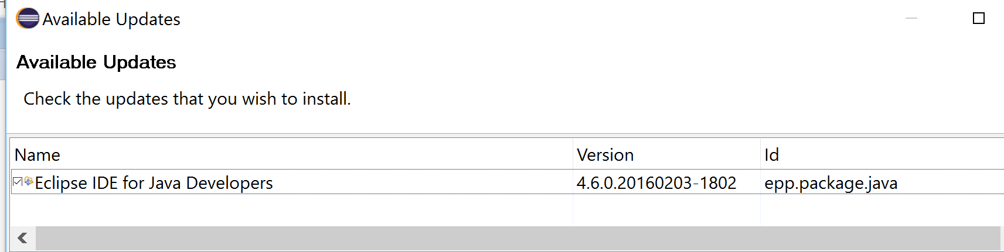

1. Next go to Help > Install New Software… Then click on Add.. and at the pop up Add Repository dialog box, enter **FX** for Name and for Location include the following url (as shown below) to install the ‘latest’ version release for JavaFX.

<http://download.eclipse.org/efxclipse/updates-released/3.0.0/site>

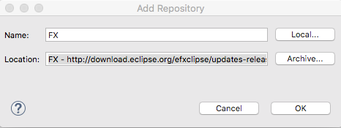

Click OK to accept entries. Then in your Available Software screen, check all the feature add ons and shown next.

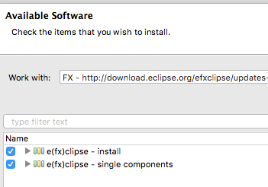

Keep the default check boxes checked at the Details portion of your screen and press Next >. Press Next > again to install all items.

At the next screen, accept the EULA agreement and then click on Finish to install the software. Wait for the udpated to occur and restart Eclipse when prompted.

**Starting a JavaFX project**

To start a JavaFX project go to **File > New > Other…** From the Wizards available that now is appearing scroll down to the **JavaFX** folder, click that open then select **JavaFX Project**. Sample snapshot follows.

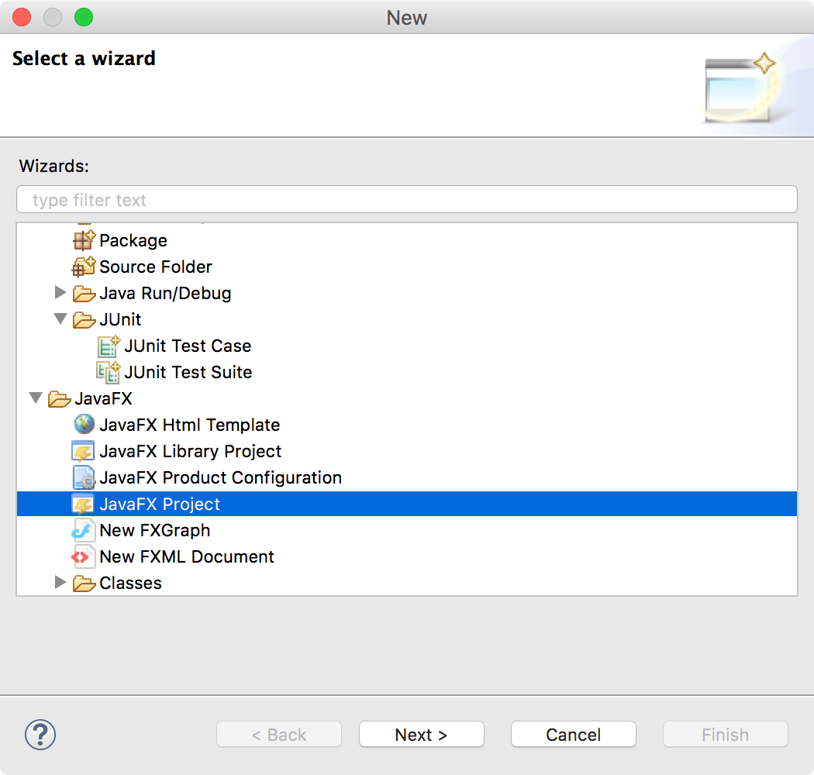

Click Next > and enter a desired Project Name at this point. Click Finish to complete the project creation.

Example project creation tree

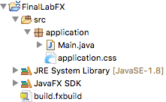

Example Main.java

package application;

import javafx.application.Application;

import javafx.stage.Stage;

import javafx.scene.Scene;

import javafx.scene.layout.BorderPane;

public class Main extends Application {

@Override

public void start(Stage primaryStage) {

try {

BorderPane root = new BorderPane();

Scene scene = new Scene(root,400,400);

scene.getStylesheets().add(getClass().

getResource("application.css").toExternalForm());

primaryStage.setScene(scene);

primaryStage.show();

} catch(Exception e) {

e.printStackTrace();

}

}

public static void main(String[] args) {

launch(args);

}

}